**Sprint 3 Report**

**Product Name:** SummarAIze

**Sprint Completion Date:** May 27th, 2025

**Revision Number:** V1.1

**Revision Date:** May 28th, 2025

**Actions to stop doing:**

* The team should stop being absent to standups without notice, because it makes the standups far less productive.

**Actions to start doing:**

* The team should start updating each other more frequently, so that we have a better idea of how much the progress has progressed.

**Actions to keep doing:**

* The team should continue holding regular standups to update our progress.
* The team should continue updating the JIRA board with tasks and their completion status.

**Work completed/not completed:**

* **Work Completed**
  + **As a researcher, I want to see citations from the original paper in the summary so that I can refer back to the sources accurately.**
    - Task 1: Update prompt to LLM to add citations (2 hr)
  + **As a user, I want to ask questions about the paper so that I can clear up any confusion and refine the summary.**
    - Task 1: Add another API call to allow Q&A based on summary (2 hr)
    - Task 2: Create UI for chatbot (2 hr)
    - Task 3: Allow “chatbot” to make changes to summary (3 hr)
* **Work Incomplete**
  + **As an educator, I want to be able to create a visual representation so that I can make presentations so that complex concepts are simplified for students.**
    - Task 1: Put visuals in frontend (1 hr)
    - Task 2: Research and add API to generate images (2 hr)
    - Task 3: Research and use Python libraries to create videos (3 hr)
    - Task 4: Add animation over visuals (4 hr)
    - Task 5: Integrate any visual components with the voiceover (3 hr)
  + **As a user, I want to get suggestions for related research papers so that I can explore the topic further.**
    - Task 1: Parse through citations at the end of the paper (1 hr)
    - Task 2: Connect to API to fetch papers based on keywords (3 hrs)
    - Task 3: Update frontend to display suggestions (1 hr)
* **Work completion rate: 50%**
  + **User Stories Completed:** **1**
  + **Ideal work hours: 25 hrs**
  + **Total Number of Days: 14 days**
  + **Average user stories / day: 0.25/day**
  + **Average work hours / day: 1.75 hour**

**Scrum Board:**

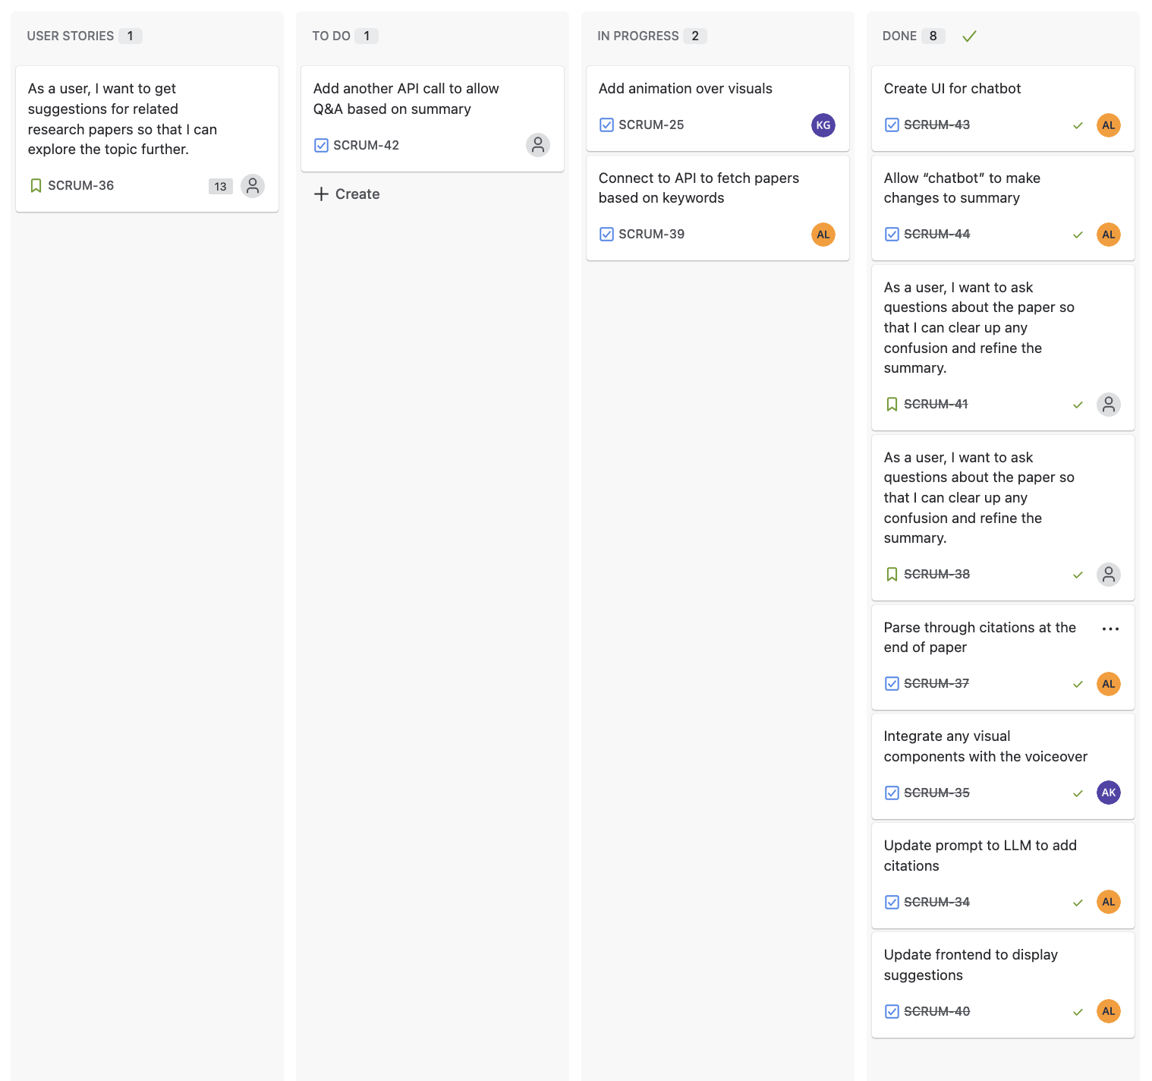

**Burn up Chart:**

